Date: 17 / March / 2023

**Subject: Project Completion Certificate**

**TO WHOM SO EVER IT MAY CONCERN**

This is to certify that **MS OVEIYA R (REG NO: 2101222078015)** Student of **M.SC (Computer Science)** of **Sri Sankara arts and science college** has Completed her project work from **02 December 2022 to 09 March 2023.**

**Domain:** Python

**Title:** **Prediction of Fire Detection Using Deep Learning.**

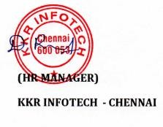Thank you for Engaging KKR INFOTECHs